Toshiba 4400 Series
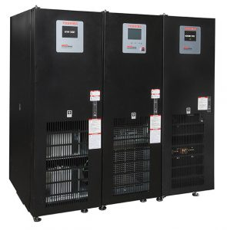The Toshiba 4400 Series uninterruptible power system (UPS) is the next-generation three-phase UPS. The double-conversion, all insulated-gate bipolar transistor (IGBT) 4400 Series UPS features a digitally controlled IGBT input rectifier, an intelligent low harmonic pulse-width modulation (PWM) output, state-of-the-art electronic battery isolation circuitry, and an easy to navigate local touchscreen interface.
The small footprint and total front access mechanical design requires zero rear clearance and includes features such as top, bottom, and/or side cable entry, standard sized air filter provisions, and lockable keyed doors. Customization is available through a number of options, such as internal battery backup, internal transformers for specific voltage applications, and remote monitoring with the Toshiba RemotEye® 4 multi-protocol UPS monitoring solution.

Toshiba 4400 Series Features
- 0.9 Power Factor
- High Efficiency
- Small Footprint
- Easily Installed

Toshiba 4400 Series Specifications
Model Number  4400- | X3X150XA | X3X200XA | X3X250XA | X3X300XA | X3X500XA | X3X800XA
Capacity | 15 kVA  (13.5 kW) | 20 kVA  (18 kW) | 25 kVA  (22.5 kW) | 30 kVA  (27 kW) | 50 kVA  (45 kW) | 80 kVA  (72 kW)
Topology | True On-Line, Double-Conversion, All-IGBT Technology
Input Voltage (Std) | 208/120V Three-phase, Four-Wire + Ground Input*
Voltage Range | -15% to +10% (Without Using Battery)
Power Factor | > 0.98
Output Voltage (Std) | 208/120 V: Three-Phase, Four-Wire + Ground**
Frequency | 50/60 Hz, ±0.1% Auto-Sensing Standard. (50/60Hz Selectable, for use as Frequency Converter)
Voltage Regulation | ±2.0%
Power Factor | 0.9 Lagging
Temp Range | 32° to 104°F (0° to 40°C)
Dimensions | 20.12″ (W) x 37.4″ (D) x 65.06″ (H) (511mm x 950mm x 1653mm) |  |  |  | 32.1″ (W) x 31.8″ (D) x 73.6″ (H)  (816mm x 807mm x 1870mm)
Weight | 720 lbs. (326 kg) |  |  |  | 1350 lbs.  (612 kg) | 1500 lbs.  (680 kg)

